MINOR PROJECT REPORT
Infrastructure Deployment & Basic Logging on Microsoft Azure

Student Details

- Name: Aanchal dewangan
- ERP : 6700440
- Group Number: G6

Introduction

This Minor Project focuses on deploying a small-scale enterprise cloud infrastructure using

Microsoft Azure.
The project simulates a real-world company environment where students act as the Infrastructure Team, responsible for deploying servers, networking, and logging mechanisms.

This phase intentionally avoids any form of security hardening so that vulnerabilities and misconfigurations can later be exploited and mitigated during the Major Project phase.

Project Objective

The objective of this project is to:

- Design and deploy a functional mini-company infrastructure on Microsoft Azure
- Deploy three Linux-based virtual machines with defined enterprise roles
- Configure basic logging mechanisms only

Enable centralized log collection using SIEM
- Prepare an intentionally unsecured environment for cyber-attacks and SOC analysis

Resource Group Configuration

As per project compliance rules, exactly one Azure Resource Group was created.

- Resource Group Name: Skygrid-Solutions
- Region: Central India All Azure resources including:
- Virtual Machines
- Virtual Network
- Subnets
- Network Security Groups
- Public IP addresses

were created inside this Resource Group only.

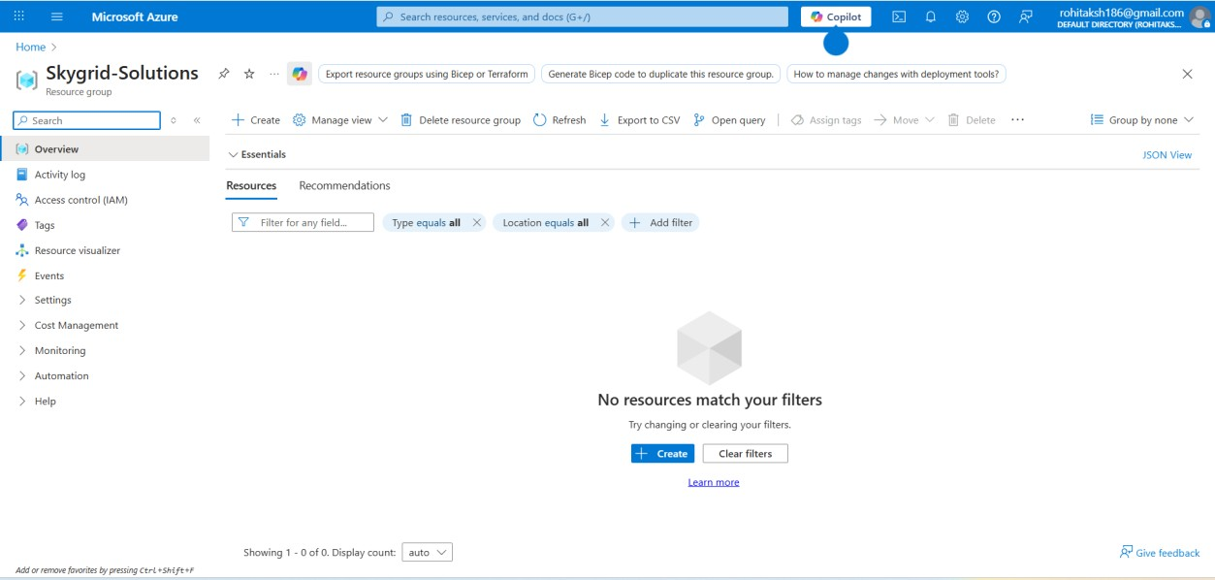

Azure Portal showing the Resource Group Skygrid-Solutions with student account name visible.

Network Architecture Design

Virtual Network Creation

A Virtual Network was created to host the company infrastructure.

    - VNet Name: Skygrid-Solutions-VNet
    - Address Space: 10.0.0.0/16

Subnet Configuration

Two subnets were created to separate internal and external services.

Subnet Name | Address Range | Purpose

Inernal-Subnet | 10.0.1.0/24 | Internal services and SIEM
DMZ-Subnet | 10.0.2.0/24 | Public-facing web server

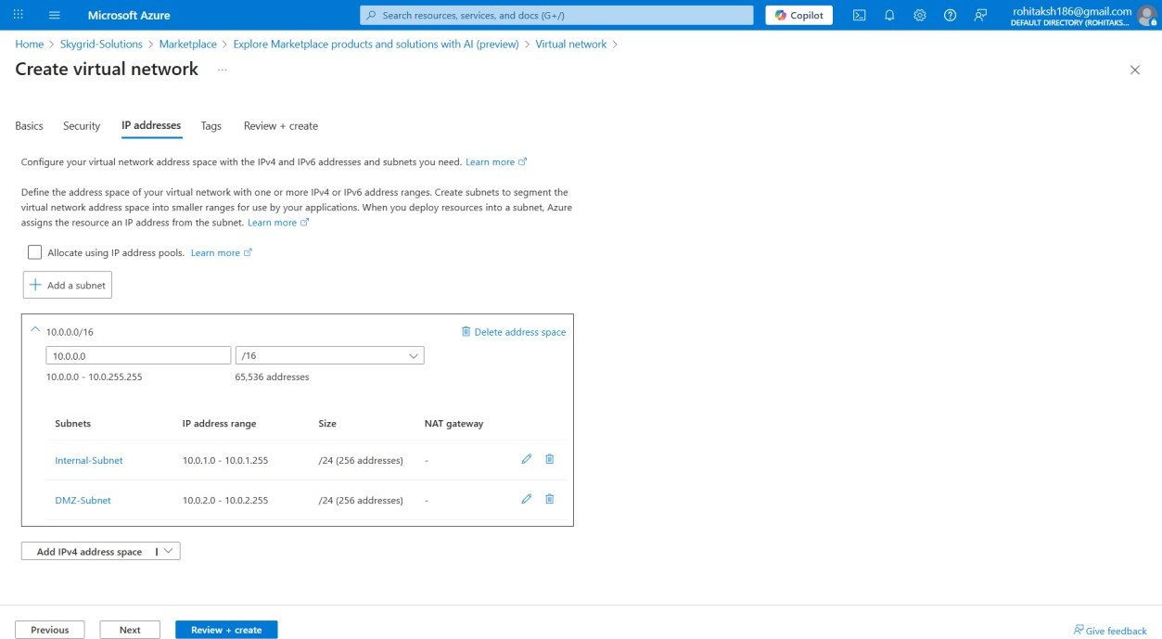

Virtual Network showing Internal and DMZ subnets under the Skygrid-Solutions resource group.

Network Security Groups (Basic Configuration)

Basic Network Security Groups (NSGs) were created to allow required traffic without any hardening.

Internal Subnet NSG

- SSH (Port 22) – Allowed from any source
- All outbound traffic – Allowed

DMZ Subnet NSG

- SSH (Port 22) – Allowed
- HTTP (Port 80) – Allowed
- HTTPS (Port 443) – Allowed
- All outbound traffic – Allowed

No restrictive firewall rules were applied.

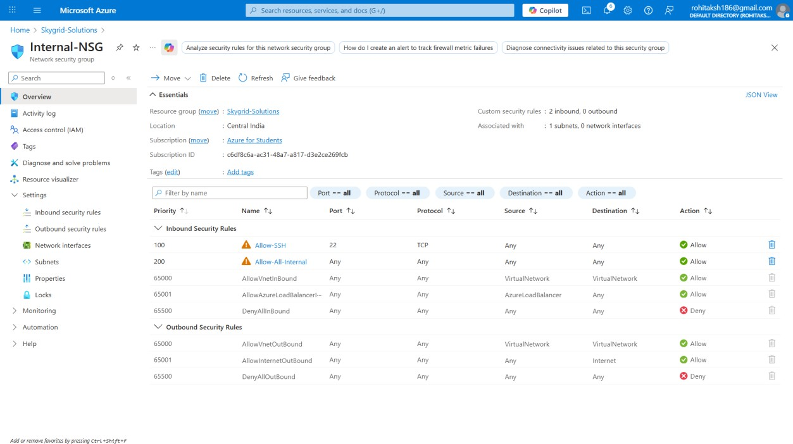

Internal-NSG showing unrestricted inbound and outbound access.

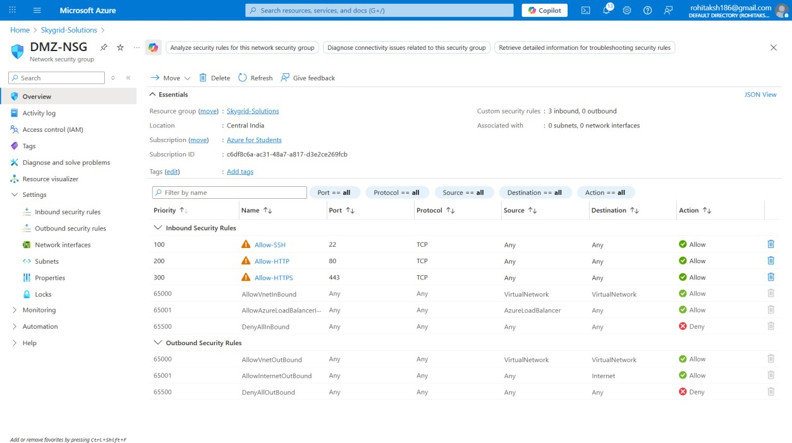

DMZ-NSG showing unrestricted inbound and outbound access.

Virtual Machine Deployment

Exactly three Linux virtual machines were deployed as required.

Common VM Configuration

    - Operating System: Ubuntu 22.04 LTS
    - Authentication: Username and Password
    - Public IP Address: Enabled
    - Resource Group: Skygrid-Solutions

VM Inventory

VM Name | OS | Purpose | Private IP | Subnet | Size
VM-Internal-Server | Ubuntu | FreeIPA + File Server | 10.0.1.x | Internal | B1s
VM-Web-Server | Ubuntu | Web Server | 10.0.2.x | DMZ | B1s
VM-SIEM | Ubuntu | SIEM + Analyst | 10.0.1.x | Internal | B2s

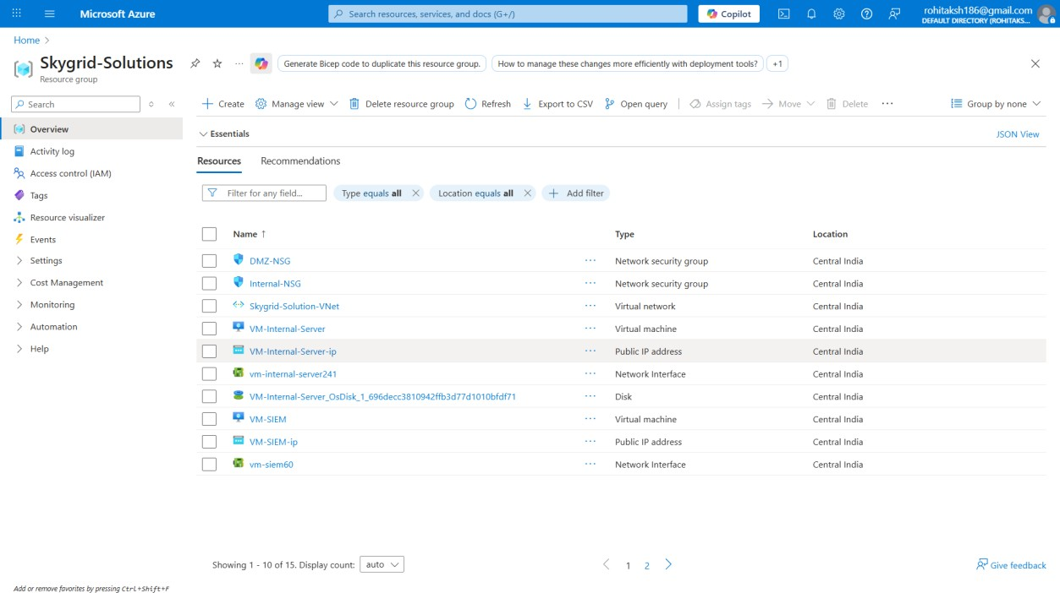

Azure Portal showing all three virtual machines deployed in the correct subnets.

Server Roles and Configuration

VM 1 – Internal Server

Roles Implemented:

    - FreeIPA (LDAP + Kerberos)
    - Samba File Server
    - Internal service hosting

This server simulates corporate identity management and internal file services.

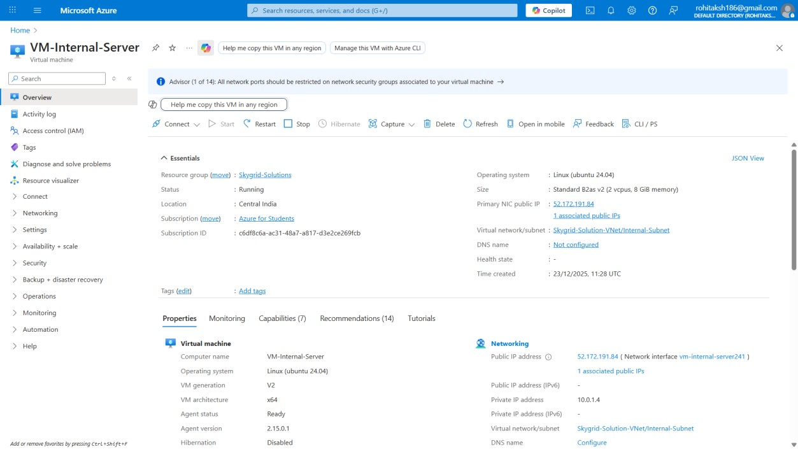

VM 2 – Web Server (DMZ)

Roles Implemented:

    - Apache Web Server
    - Static web page hosting

The web server generates:

    - Access logs
    - Error logs

This server represents an external-facing application server.

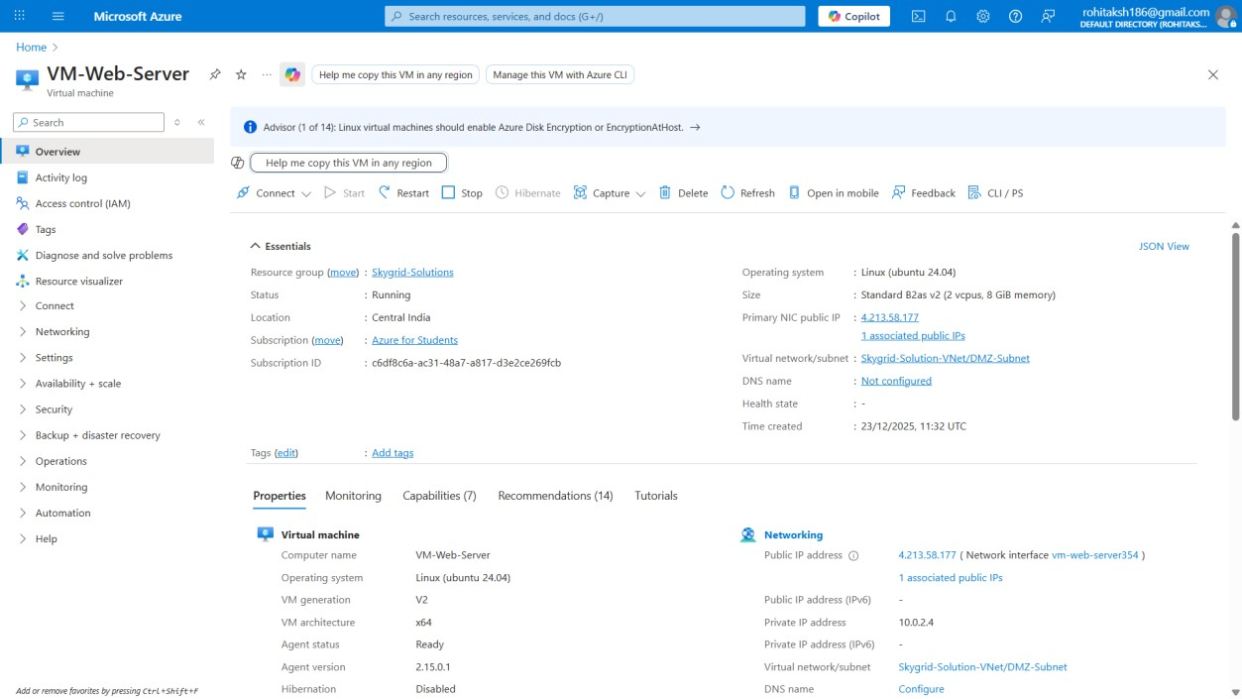

VM 3 – SIEM + Analyst Workstation

Roles Implemented:

    - Wazuh SIEM
    - Centralized log monitoring and analysis

This server acts as the Security Operations Center (SOC) workstation.

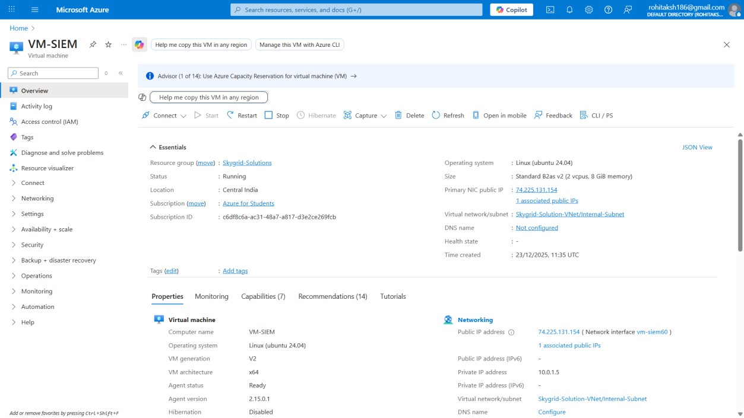

Basic Logging Configuration
Only default logging mechanisms were enabled.

Logs Generated

VM | Logs Generated
VM-Internal | Syslog, Authentication logs, Auditd
VM-Web | Apache access and error logs
VM-SIEM | Centralized collected logs

  - Log Forwarding

    - Wazuh agents were installed on:

      - VM-Internal-Server
      - VM-Web-Server

    - Logs were forwarded to:

      - VM-SIEM (Wazuh Manager)

No firewall rules, SSH hardening, or security baselines were applied.
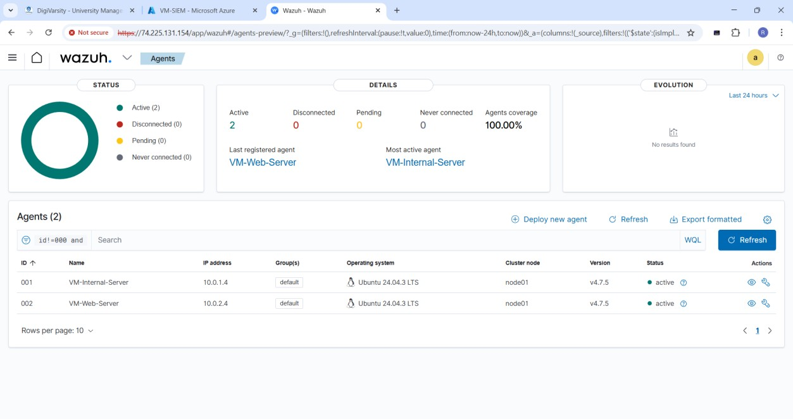

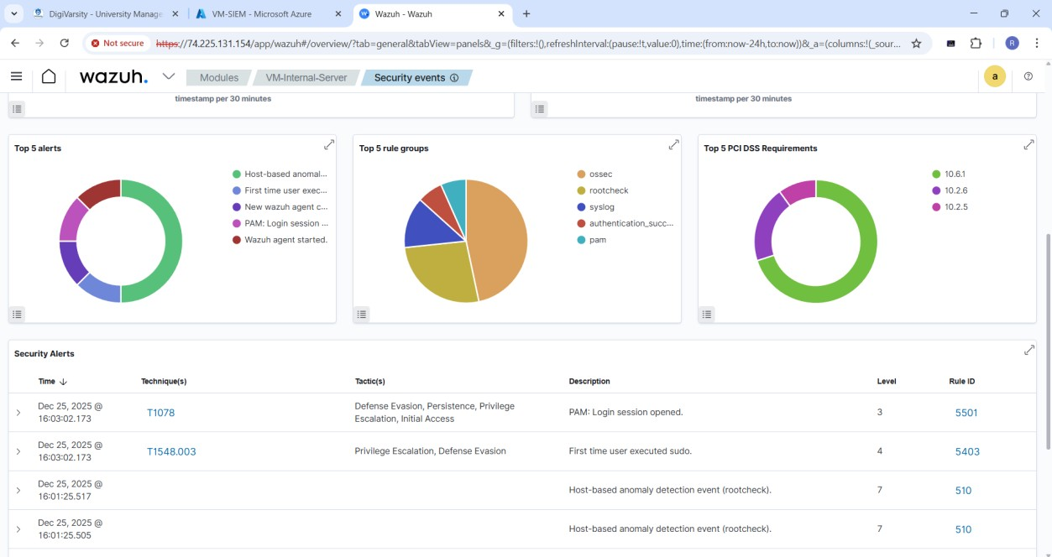

Wazuh SIEM dashboard displaying logs received from Internal and Web servers.

Network Diagram

A network diagram was created to represent:

- Virtual Network
- Subnets
- VM placement
- Traffic flow

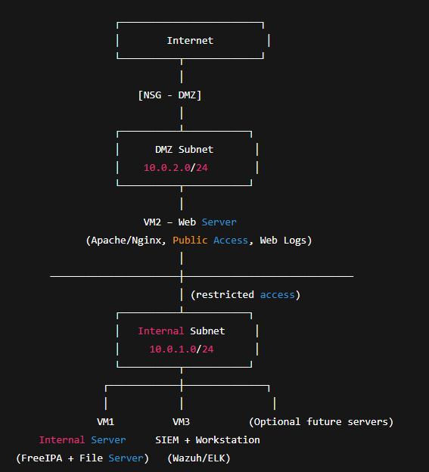

Deliverables Summary

The following deliverables were completed:

- Infrastructure Deployment Report
- Network Diagram
- VM Inventory
- Logging Summary
- Screenshot Proof with student name visible

Conclusion

This project successfully deployed a mini enterprise cloud infrastructure on Microsoft Azure with basic logging enabled.
The environment was intentionally left unsecured, fulfilling the requirement for future
attack simulation, log analysis, and SOC operations in the Major Project phase. Through this project, practical knowledge was gained in:

- Cloud infrastructure deployment
- Linux server roles
- Network segmentation
- Centralized logging using SIEM

Declaration

I declare that this project has been completed by me using my Azure Student Account, and all screenshots submitted clearly show my name and resource group as required.

Date: 22 Dec 2025

